EASO Management Board welcomes strengthening of Agency's good governance

* 19TH FEBRUARY 2019

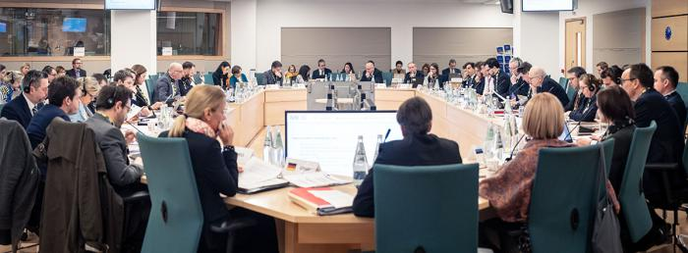

***The 31st meeting of the European Asylum Support Office (EASO) Management Board was held in Malta on 18-19 February 2019. The meeting, which focussed heavily on administrative and governance matters, welcomed the strong progress that has been made by the Agency over the past few months in implementing an ambitious set of reforms contained in its Governance Action Plan.***

EASO’s Governance Action Plan was approved by the Management Board in 2018, and aims at reinforcing the internal governance of the Agency, rebuilding internal capacity and consolidating trust. Specifically it addresses areas such as internal controls, procurement procedures and recruitment in order to meet increased demands placed on EASO. In the latter case, the Agency has been undergoing an unprecedented recruitment drive over the past few months.

The meeting of the Management Board welcomed the significant progress made in implementing the action points of the Plan, under the stewardship of Mr. Jamil Addou, EASO’s Executive Director *ad interim*. Work on the implementation of the Plan will continue as a matter of priority over the coming months.

The Management Board also made a [number of appointments](https://www.easo.europa.eu/news-events/easo-management-board-selects-new-executive-director-and-elects-new-chairperson), most notably through the election of Dr. David Costello as its new Chairperson, and Mr. Mikael Ribbenvik as the new Deputy Chairperson. Furthermore, Ms. Nina Gregori was selected by the Management Board to serve as the new Executive Director of EASO. A final decision on her appointment will be taken following an opinion of the European Parliament.

The Management Board also discussed the latest developments in EASO’s activities, including the recent publication of the [latest asylum trends in the EU+ in 2018](https://www.easo.europa.eu/news-events/eu-asylum-figures-2018-applications-return-2014-levels-decreasing-10-over-previous-year) as well as EASO’s [2019 Operating Plans](https://www.easo.europa.eu/news-events/easo-steps-operational-support-cyprus) for Cyprus, Greece and Italy.

Amongst the important decisions taken by the Management Board was the endorsement of a new Country Guidance on Nigeria. This publication, which is the second of its type following a similar publication on [Afghanistan](https://www.easo.europa.eu/sites/default/files/easo-country-guidance-afghanistan-2018.pdf), represents the joint assessment of the situation in Nigeria by EU+ Member States. The ultimate aim of [country guidance publications](https://www.easo.europa.eu/country-guidance) is to foster convergence in the application of the criteria for qualification for international protection. Furthermore, the meeting also endorsed EASO’s new External Action Strategy.